**IOT BASED INDUSTRY AUTOMATION USING RASPBERRY PI**

INDEX:

* Introduction
* Block diagram
* Raspberry pi
* Humidity sensor
* Light sensor
* Flame sensor
* Motor
* Led
* Working
* Coding
* Future scope
* Conclusion
* Result
* image of the project
* References

ABSTRACT:

**Internet of Things (IoT) is propagating and blooming technology, in previous years. IoT is the collection of the sensors data through embedded system and this embedded system upload the data on internet. There are many challenges to IoT and Industrial Automation for example Data and service security, Trust, data integrity, information privacy, scalability and interoperability Automation Domain Constrains. This paper combines the concept of Raspberry Pi Industrial workstation and Industrial Automation using IoT. The system uses the raspberry pi as controller and server, the programming is done in the python language. The webpage is designed in HTML, Query, ajax and Flask as framework for rendering the HTML template in python. All sensor data are collected through raspberry pi. All the use full data are access remotely through internet of thing platform. Here the blade ageing system of cutter tool is taken to as industrial example and current is monitored to the webpage using raspberry pi as server. This system demonstrates how industry works using automation.**

INTRODUCTION:

**A large range of industrial IoT application are developed within last few years. It was initiated from RFID technology, where microchips transmit the identification information to a reader through wireless communication. And further technology goes to the wireless sensor networks (WSNs), which mainly use interconnected intelligent sensors to sense and for monitoring. Internet of Things (IoT) is a concept that considers pervasive presence in the environment of a variety of things/objects that through wireless and wired connections and unique addressing schemes are able to interact with each other and cooperate with other things/objects to create new applications, services and reach common goals. The IoT applications are; smart cities, smart energy and the smart grids, smart transportation and enabling traffic management and control. The R-Pi, is a single-board computer which is uses Linux based OS and that can be directly used in electronics projects because it has general purpose input/output (GPIO) pins right on the board This project involves the detail design and construction of an Industrial automation system using Raspberry Pi board and Internet connection. The automation may be semi or fully controlled and monitors the utility grid connected sensors. This project is a demonstration of how to design and build a multipurpose remotely controlled system that can switch any industrial acuter by accessing an raspberry pi, which is programmed to control the systems inside industrial environment, when the person is away from work station and enable a person to get the related information on phone. The system will provide feedback indicating the current state of the system stopped or functioning.**

**BLOCK DIAGRAM:**

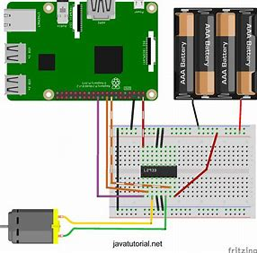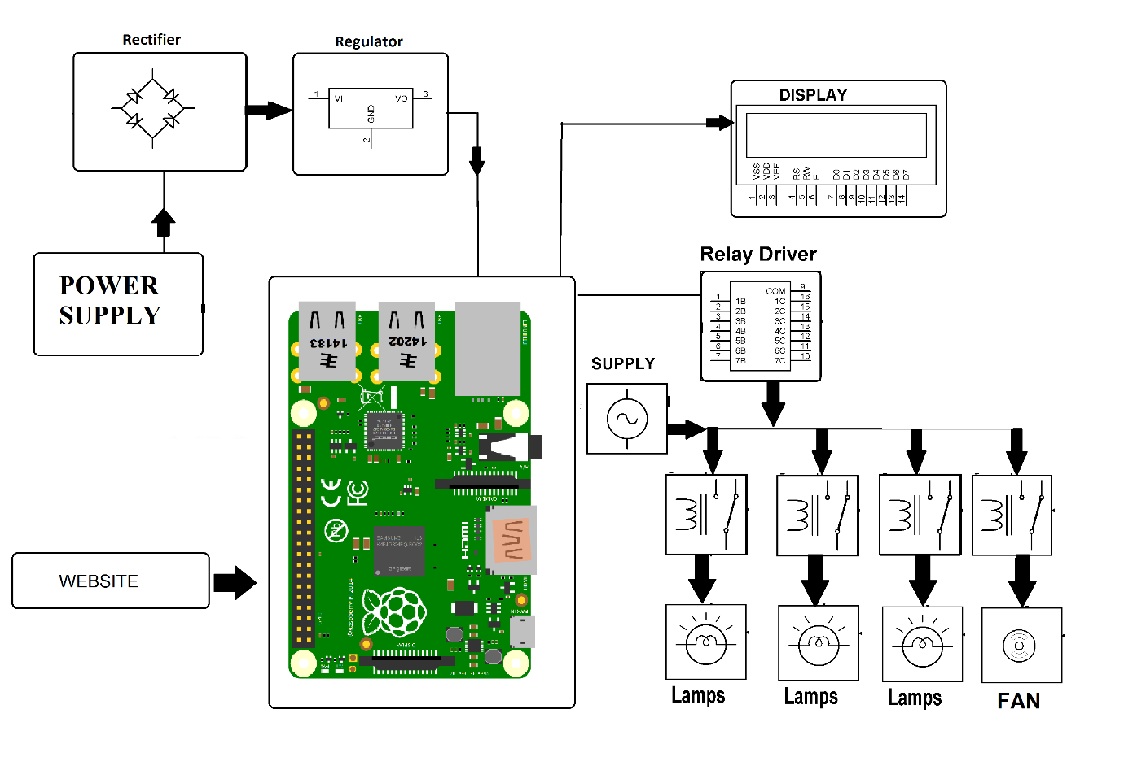

The Raspberry Pi 3 is the third-generation Raspberry Pi. It replaced the Raspberry Pi 2 Model B in February 2016.

* **Quad Core 1.2GHz Broadcom BCM2837 64bit CPU**
* **1GB RAM**
* **BCM43438 wireless LAN and Bluetooth Low Energy (BLE) on board**
* **40-pin extended GPIO**
* **4 USB 2 ports**
* **4 Pole stereo output and composite video port**
* **Full size HDMI**
* **CSI camera port for connecting a Raspberry Pi camera**
* **DSI display port for connecting a Raspberry Pi touchscreen display**
* **Micro SD port for loading your operating system and storing data**
* **Upgraded switched Micro USB power source up to 2.5A**

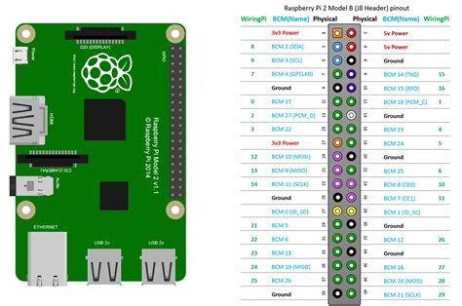

**HUMIDITY SENSOR:**

|  |
| --- |
| **DHT11 - Humidity and Temperature Sensor. The DHT11 is a basic, low-cost digital temperature and humidity sensor. It uses a capacitive humidity sensor and a thermistor to measure the surrounding air and spits out a digital signal on the data pin.**    **It’s fairly simple to use but requires careful timing to grab data. The only real downside of this sensor is you can only get new data from it once every 2 seconds.**    **FEATURES:**  **• Full range temperature compensated**  **• Relative humidity and temperature measurement**  **• Calibrated digital signal**  **• Outstanding long-term stability**  **• Extra components not needed**  **• Long transmission distance**  **• Low power consumption**  **• 4 pins packaged and fully interchangeable** |

**LIGHT SENSOR:**

**A light dependant resistor also known as a LDR, photoresistor, photoconductor or photocell, is a resistor whose resistance increases or decreases depending on the amount of light intensity. LDRs (Light Dependant Resistors) are a very useful tool in a light/dark circuits. A LDRs can have a variety of resistance and functions. For example, it can be used to turn on a light when the LDR is in darkness or to turn off a light when the LDR is in light. It can also work the other way around so when the LDR is in light it turns on the circuit and when it’s in darkness the resistance increases and disrupts the circuit.**

**DC MOTOR:**

**• When the ﬁrst start up, they draw a lot more current, up to 10x more.**

**• If you “stall” them (make it so they can’t turn), they also draw a lot of current.**

**• They can operate in either direction, by switching voltage polarity • Usually spin very fast: >1000 RPM.**

**• To get slower spinning, need gearing.**

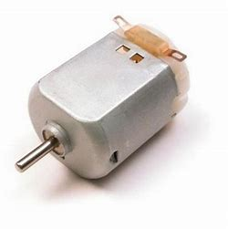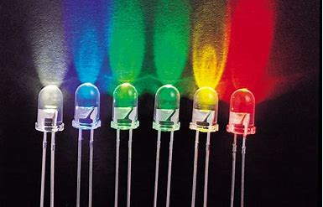

**LED:**

**A light-emitting diode (LED) is a** [**semiconductor**](http://whatis.techtarget.com/definition/semiconductor) **device that emits visible light when an electric** [**current**](http://whatis.techtarget.com/definition/current) **passes through it. The light is not particularly bright, but in most LEDs it is monochromatic, occurring at a single** [**wavelength**](http://searchnetworking.techtarget.com/definition/wavelength)**. The output from an LED can range from red (at a wavelength of approximately 700 nanometres) to blue-violet (about 400 nanometres). Some LEDs emit infrared (**[**IR**](http://searchnetworking.techtarget.com/definition/infrared-radiation)**) energy (830 nanometres or longer); such a device is known as an infrared-emitting diode (IRED).**

**WORKING:**

**The main objective is to save valuable time and money in largescale industries by using IOT technology including a mini computer called as raspberry pi. We can find the temperature and humidity of an industry by using humidity sensor to monitor air conditioners in industry automatically.**

* **It mainly depends on IOT when we give proper connections.** **without failure by using cayenne IOT builder. when we give**

**Proper channel number in that app and icon after that,**

**We have to add actuator. when we on the switch led will blink.**

**That means that we can run the industry automatically. Wherever we present and similarly we can run the motor.** **From this we can say that we can find the working times of workers and machine working.**

**CODING:**

import RPi.GPIO as GPIO

import dht11

# initialize GPIO

GPIO.setwarnings(False)

GPIO.setmode(GPIO.BCM)

GPIO.cleanup()

# read data using pin 14

instance = dht11.DHT11(pin = 14)

result = instance.read()

if result.is_valid():

print("Temperature: %d C" % result.temperature)

print("Humidity: %d %%" % result.humidity)

else:

print("Error: %d" % result.error_code)

**for light sensor:**

import RPi.GPIO as GPIO

GPIO.setmode(GPIO.BCM)

GPIO.setup(4,GPIO.IN)

for i in range(0,5):

    print GPIO.input(4)

**FUTURE SCOPE:**

**1)We can improve this project in future in various ways using multiple technologies.**

**2)By using smoke sensor and buzzer we can made fire alert system.**

**3)By using GSM module ,we can connect to machines from this we can find the wear and tear of the machines and also we can connect with fire stations in emergency they will help us.**

**4)By using temperature and humidity sensor we can find the current situation in industry.**

**5)By using stepper and shunt motors we can easily made packaging and for other Purposes.**

**CONCLUSION:**

**As mentioned in the Section II, we get the information of the SOA-IoT that is Service Oriented Architecture IoT. We also get the idea about the System overview of raspberry pi. We are aware from the new trends in the Industrial automation and IoT technologies. The authors also discuss the various challenges in the IoT and also in Industrial automation constrain. How handle this challenge is also discussed by the authors. The authors also survey the industrial marketplace considering the IoT perspective. The embedded internet network was discussed by the author in which IEC 62591 that is wireless HART standard was mention in detail. A good comparison done by the author in which why to use raspberry pi in industrial propose is explained. As raspberry pi is small in size and also consumed less power along with doing complex processing of collected data. There are lots of wastage in energy at workstation and industries by hiding the real status of the installed system through workers or may be the middle hierarchy of industries. This system try to minimize the energy waste by providing sufficient information to the owner or top level hierarchy persons via remotely and can be made appropriate decision. It also helps to analize the overview consumption of power and material requirement. In this system, blade aging of the cutter tool is monitored by observing the energy consumption of cutter tools.**

**RESULT:**

**After designing, simulating, assembling, soldering and testing the circuit. we came to conclusion that our system gives the result.**

**1)Temperature**

**2)Humidity**

**3)Light ambience**

**4)Running motor**

**5)Flame detection**

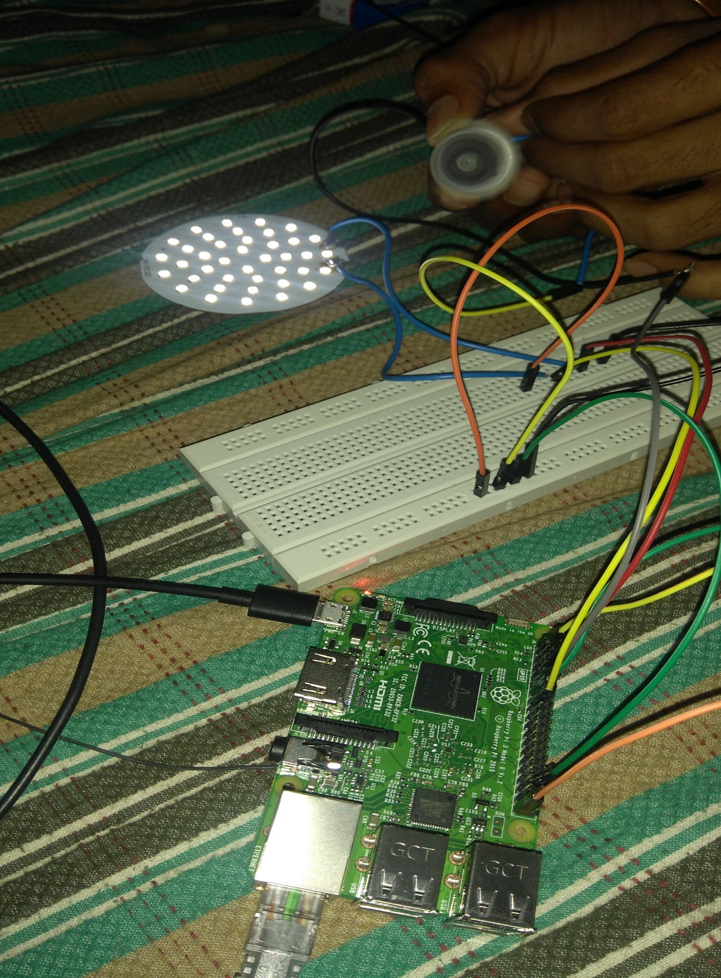

**IMAGE OF THE TOTAL RESULT**